EOCap4Africa – 9b Raster Analysis
Sample solution – Vegetation indices
Project setup
- Start QGIS and create a new project file.
- Get a background map using Web -> QuickMapServices -> OSM -> OSM-Standard.
Load Sentinel-2 bands into QGIS
- Navigate to the Sentinel-2 folder (.SAFE)., where you should select the following bands for this analysis:
    - B03 (Green, 10m)
    - B04 (Red, 10m)
    - B08 (NIR, 10m)
    - B11 (SWIR, 20m)
- If you are unsure why we need to select these bands, you can go back to the 9a slides and check out the formulas of the Vegetation Indices

Clip the raster to the study area

Since the next steps take may take a lot of computing power, we first clip the bands to the study area.

For every of the four bands we use the “Clip Raster by Mask Layer” Tool

Raster -> Extraction -> Clip Raster by Mask Layer

We set the NoData Value to 0

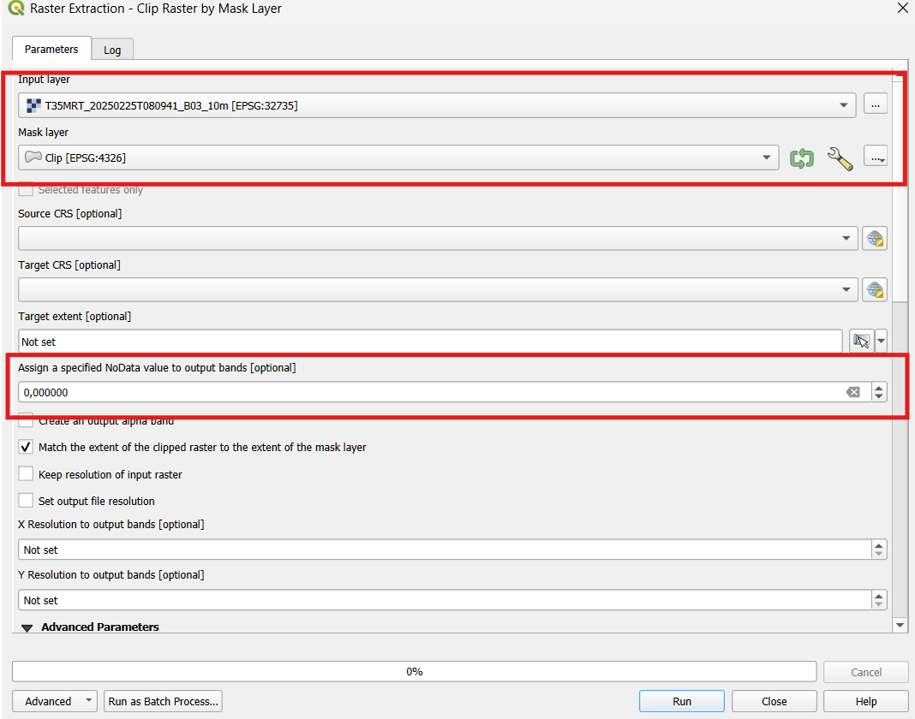

To not get confused with the new layers you can rename them (f.ex. B03_clipped)

Resample B11_clipped to 10m

- B11, with its 20m resolution, is too coarse compared to our other bands, so we need to resample it. The resampling tool is part of the SCP plugin

- First we have to create a Band Set from Band B11_clipped (look at XX when don’t remember how)

- Now we do the actual Reprojection:
-> PreProcessing -> Reproject Raster Bands. Choose the input band set of B11_clipped and set the X and Y resolution to 10 and run the tool
Simply input B11, set the X and Y resolution to 10 and run the Tool

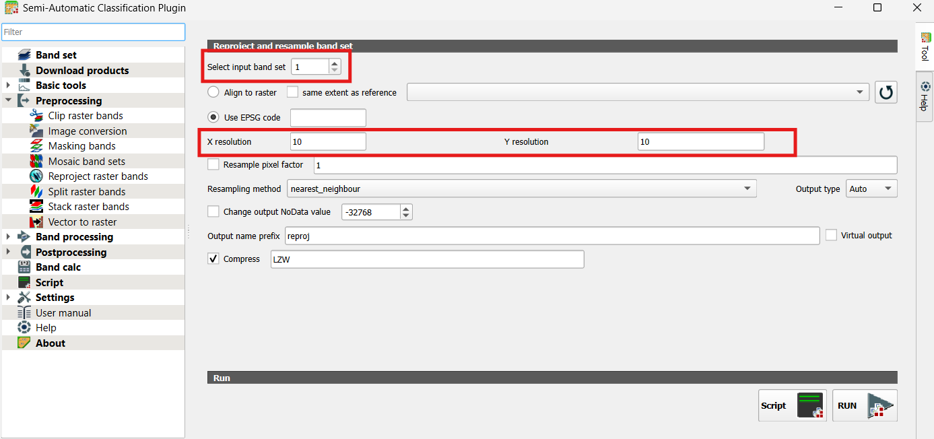

Create a virtual raster

- Next, we can merge the 4 bands into one cohesive raster image by using the tool “Build Virtual Raster” in the Miscellaneous tab of the raster tools. Input the bands (B04_clipped, B08_clipped, B11_clipped, reprojOUTPUT), select ”highest” for resolution, and remember to tick the box that ensures that all input layers will be treated as individual bands.

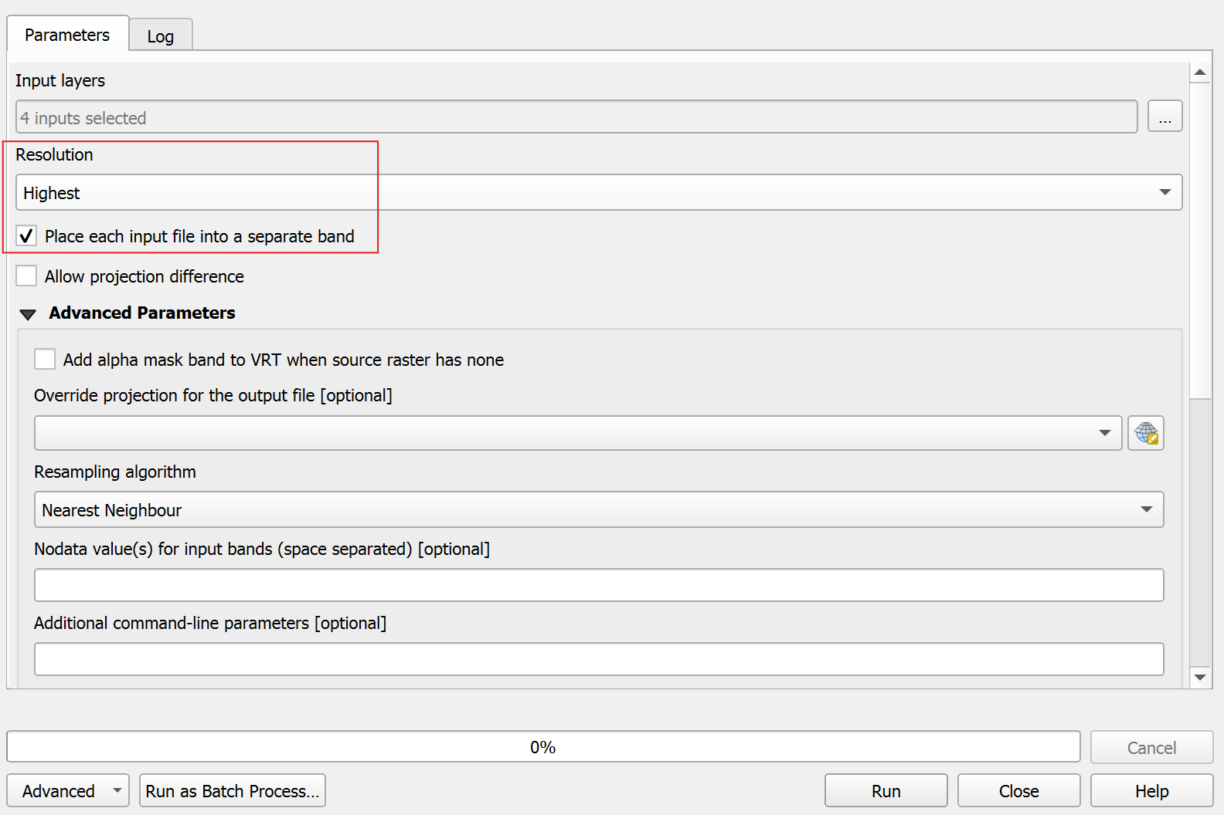

Result:
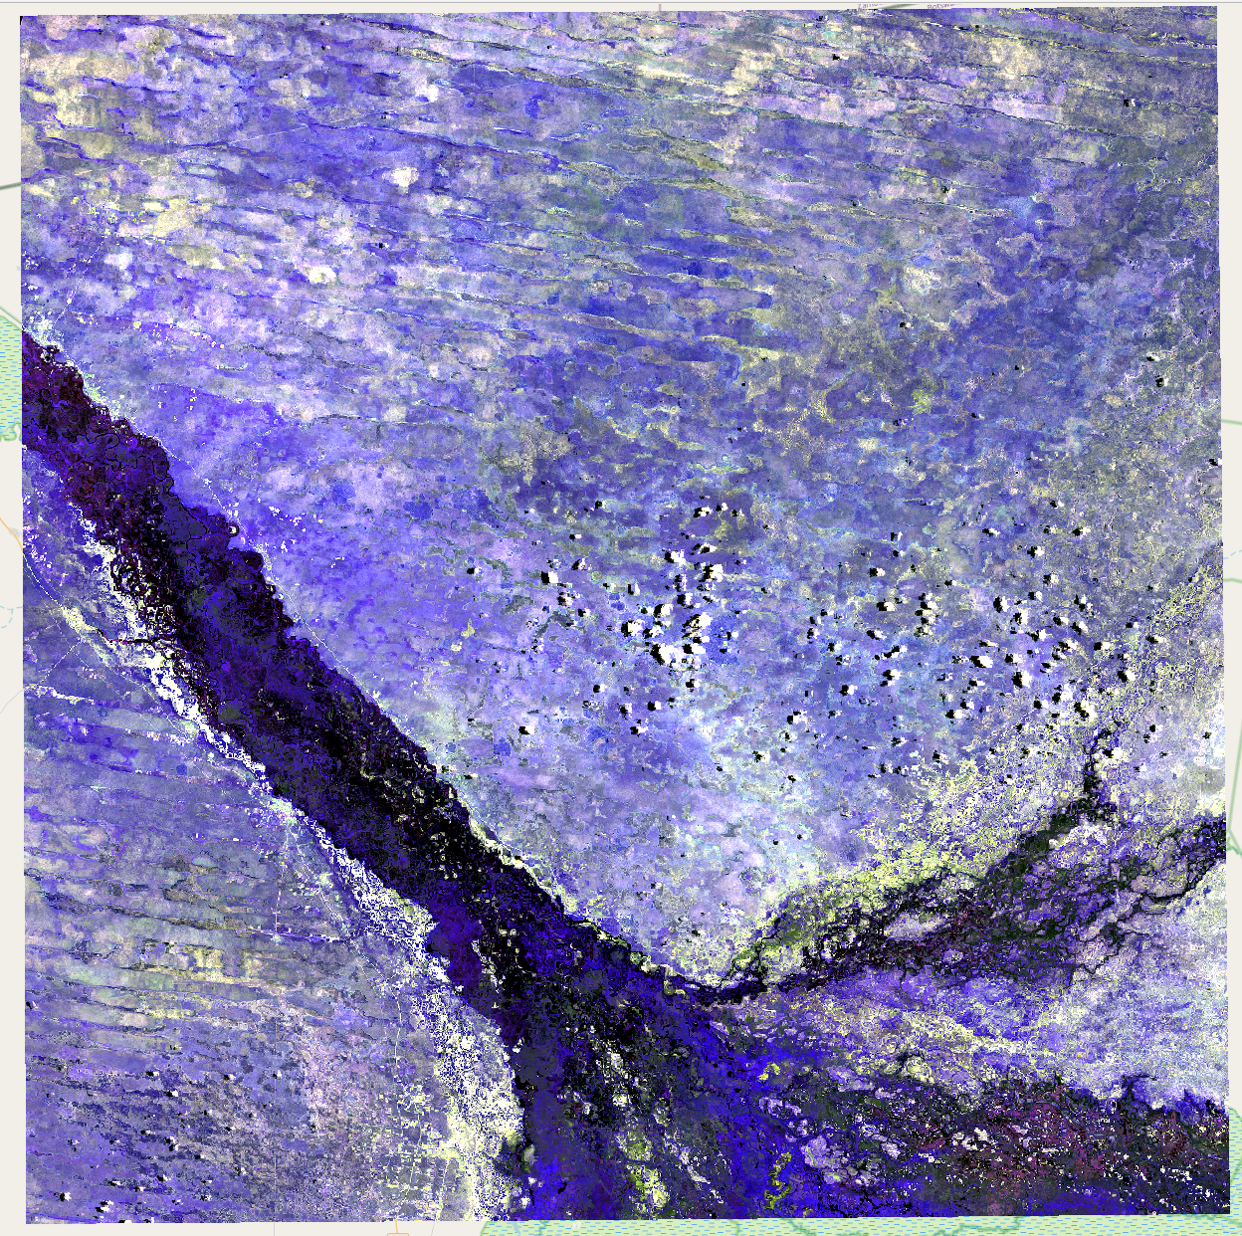

Calculate the NDVI
- For the Vegetation Index Calculations, we can use the Raster Calculator. Use the Formula provided in lecture 9a to calculate the NDVI and save the output as a new Raster file.
- Formula: ( "Raster_Study_Area@3" - "Raster_Study_Area@2" ) / ( "Raster_Study_Area@3" + "Raster_Study_Area@2" )
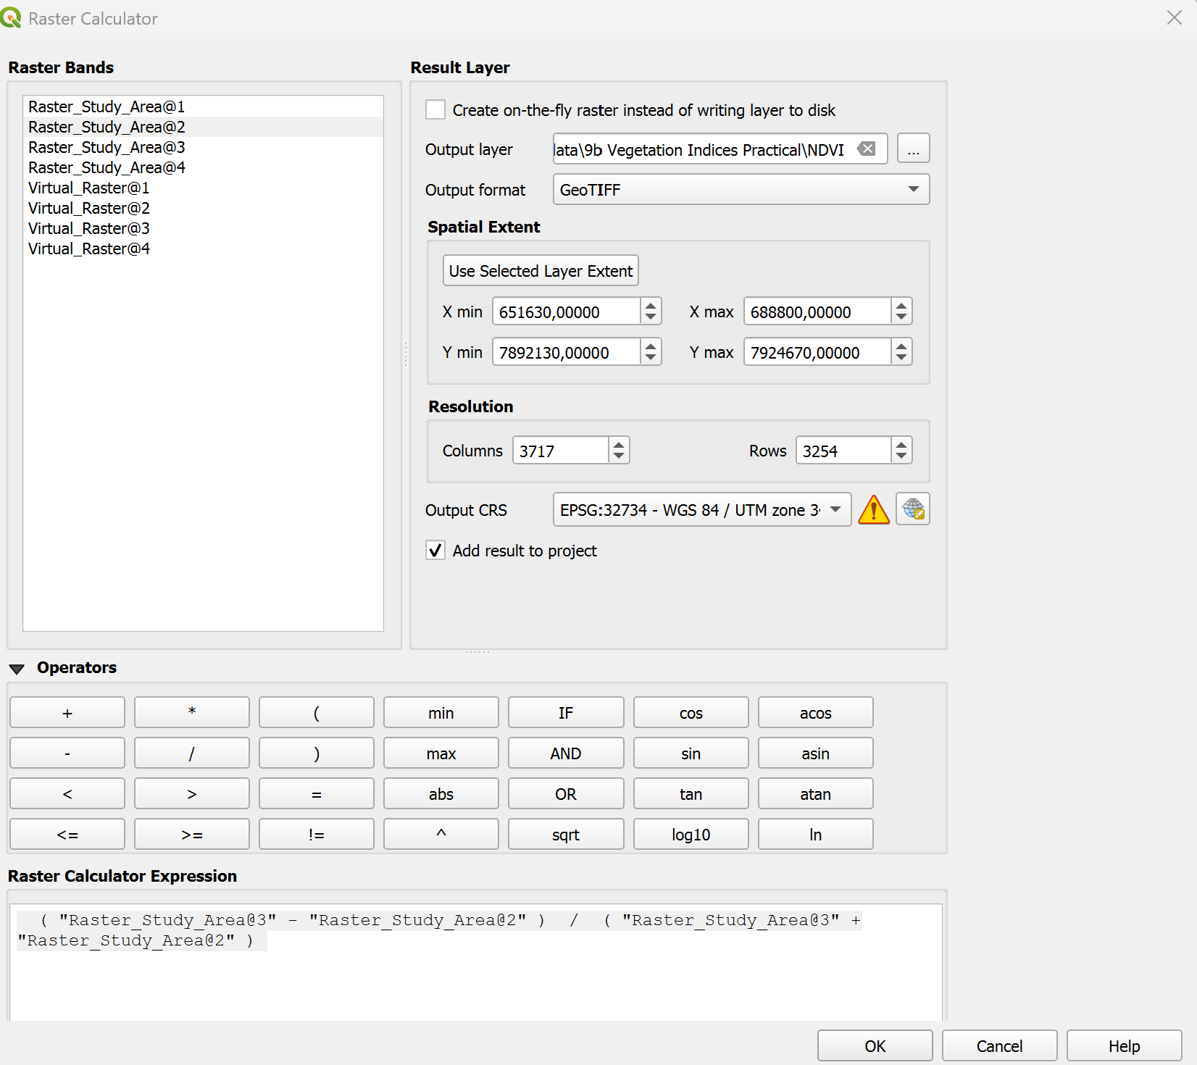

Calculate the NDWI
- For the Vegetation Index Calculations, we can use the Raster Calculator. Use the Formula provided in lecture 9a to calculate the NDWI and save the output as a new Raster file.
- Formula: ( "Raster_Study_Area@3" - "Raster_Study_Area@1" ) / ( "Raster_Study_Area@3" + "Raster_Study_Area@1" )
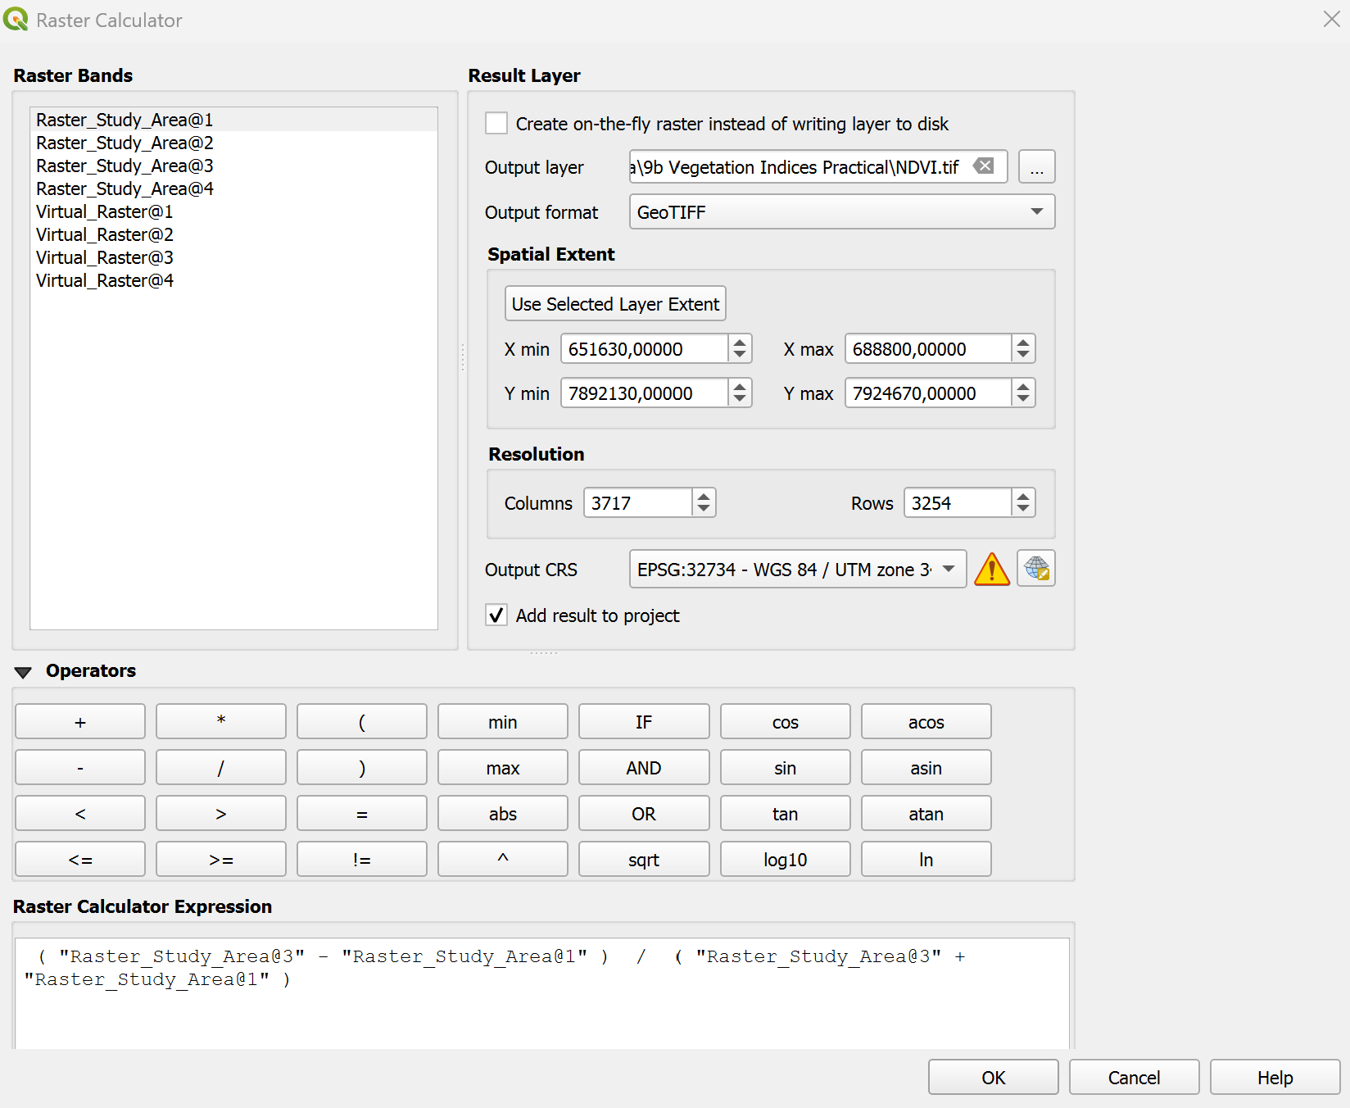

Calculate the NDMI
- For the Vegetation Index Calculations, we can use the Raster Calculator. Use the Formula provided in lecture 9a to calculate the NDMI and save the output as a new Raster file.
- Formula: ( "Raster_Study_Area@3" - "Raster_Study_Area@4" ) / ( "Raster_Study_Area@3" + "Raster_Study_Area@4" )
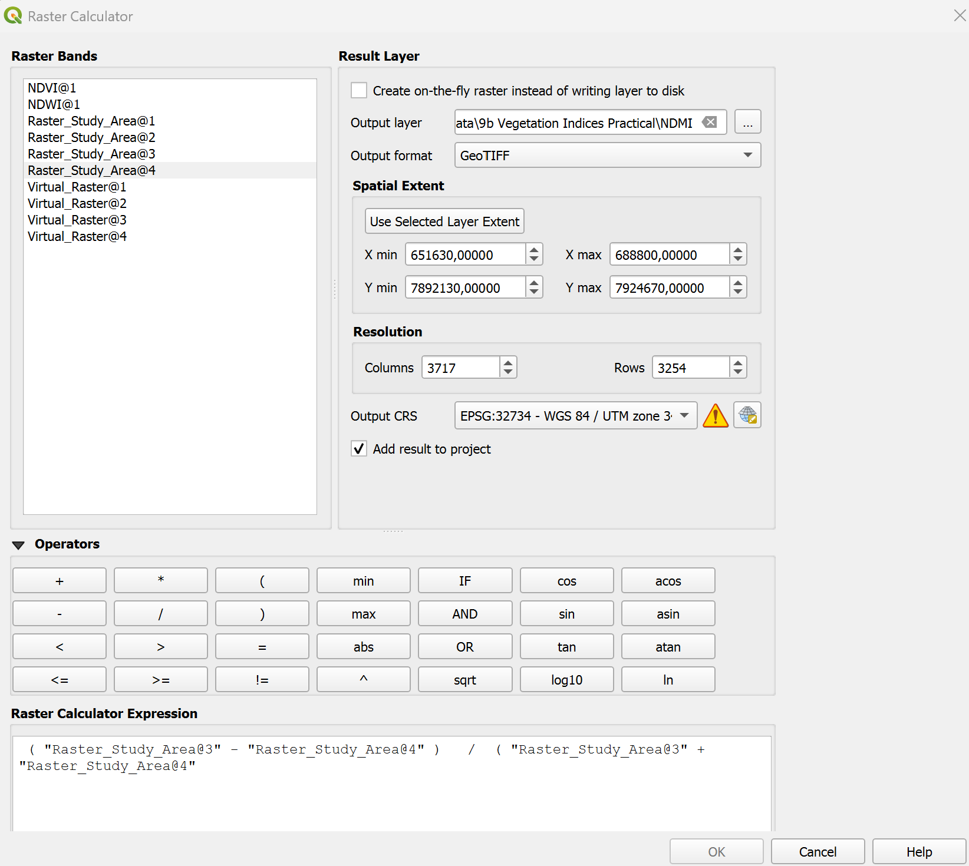

Designing the map
- In the Layer properties, set the Symbology to Singleband Pseudocolour and choose a fitting colour ramp for your Index, eg, NDVI is traditionally red to green!
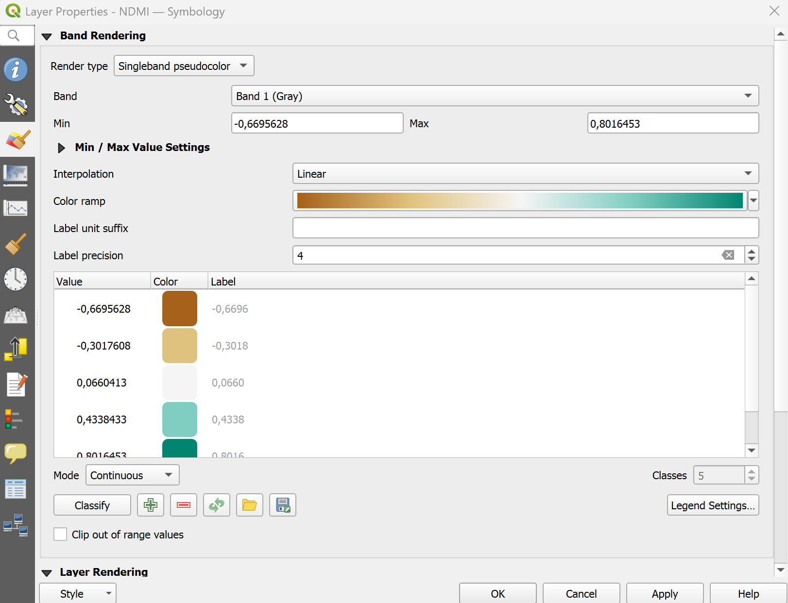
Now all that is left to do is create a map showing the three vegetation Indices side by side!

